Assignment-1

**Q1. Installation of MS SQL Server**

Solution: Please find the below steps of installation of MS SQL Server

Step 1. Download MS SQL Server from Browser

Step 2. Install SQL Server

Step 3. Select Developer under “Specify a free edition”.

Step 4. Select Instance configuration-If named instance is selected, need to enter the name for the instance, e.g. MSSQL.

Step 5. Select mixed mode in Database engine configuration and create a password (will be used later to connect server), then select add current user

Step 6. After installation completed, need to install SSMS

Step 7. Download the SSMS from Browser

Step 8. Install SSMS

Step 7. After installation, click on MS SSMS to use further.

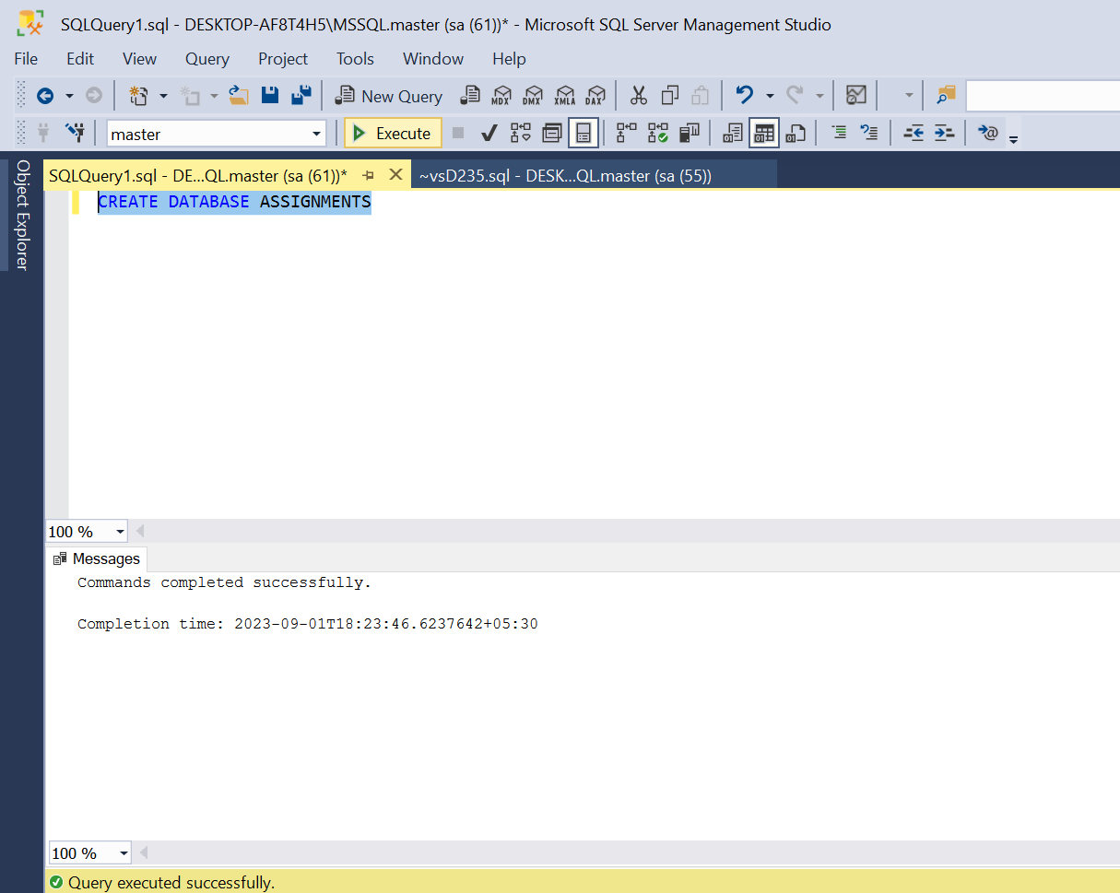

**Q2. Give the difference between Char and Varchar data type**

Solution:

Char- 1) Char is used to store only characters of a fixed length.

2) It is an abbreviation for characters

3) We can use Char data type when we know the length of the string

Varchar- 1) Varchar is used to store characters of variable length.

2) It is an abbreviation for variable characters

3) We can use Varchar when we are not sure of the length of the string

**Q3. Explain the types of SQL commands**

Solution:

1. DQL-Data query language: used to retrieve data from database.

Command-

SELECT: Selecting data from a database.

1. DDL-Data definition language: used to create, alter, delete database objects

Like, tables etc.

Commands-

CREATE: Creating a new database or new table in SQL server.

DROP: Dropping a table from a database permanently.

ALTER: Modifying the structure of a table or database.

TRUNCATE: Deleting rows from the table but not structure of the table

1. DML-Data manipulation language: used to modify the database.

Commands-

INSERT: Inserting a new row into a table

UPDATE: Updating all rows/specific row in a table by using ‘Where’ condition

DELETE: Deleting all rows/specific row in a table by using ‘Where’ condition

1. DCL-Data control language: used to grant & revoke permissions.

Commands-

GRANT: Providing specific permissions to users

REVOKE: Removing specific permissions that have been previously granted to users

1. TCL-Transaction control language: used to manage and control the transactions in database. Commands-

COMMIT: Saving the changes permanently which is made during a transaction

ROLLBACK: Used to undo changes made during transaction

SAVEPOINT: Saving the data at a particular point temporarily, so that whenever needed can be rollback to that particular point.

**Q4. Explain Nvarchar and Nchar.**

Solution:

Nvarchar and Nchar are Unicode datatype.

Nvarchar-It stands for National variable character. It takes 2 bytes per Unicode/non Unicode character

Nchar-Its stands for National character. It is a fixed length data type